- Title： TCP Port Scan
No. 2

Name:Khan Md Shahedul Islam
Stu No.: 2018380130
Class No.: 10101801
Time: 2020/11/13

School of computer science and Engineering, NWPU

Content

1 Purpose of the experiment 1
2 Steps for the experiment 1
3 Problems happened to the experiment 1
4 Results and analysis 3

Purpose:

Through discovering the TCP service by the remote host, understand the working principle of C/S communication and port scanning.

Steps of the experiment:

- The port has been kept free through which the server connects
- Putty software also can be used which can perform ac as the remote for the server.
- The server has been connected to run the code
- My server can also be searched
Source Code:
#include <iostream>
#include <string>
#include <WS2tcpip.h>
#pragma comment(lib, "ws2_32.lib")

using namespace std;

void main()
{
// string ipAddress ; // IP Address of the server
// Listening port # on the server

// Initialize WinSock
WSAData data;
WORD ver = MAKEWORD(2, 2);
int wsResult = WSAStartup(ver, &data);
if (wsResult != 0)
{
cerr << "Can't start Winsock, Err #" << wsResult << endl;
return;
}

// Create socket
SOCKET sock = socket(AF_INET, SOCK_STREAM, 0);
if (sock == INVALID_SOCKET)
{
cerr << "Can't create socket, Err #" << WSAGetLastError() << endl;
WSACleanup();
return;
}

// Fill in a hint structure
sockaddr_in hint;
hint.sin_family = AF_INET;
hint.sin_port = htons(54002);
hint.sin_addr.S_un.S_addr = INADDR_ANY;
bind(sock,(sockaddr*)&hint,sizeof(hint));
listen(sock, SOMAXCONN);

// Connect to server
sockaddr_in client;
int clientsize = sizeof(client);

SOCKET clientsocket = accept(sock, (sockaddr*)&client, &clientsize);
char host[NI_MAXHOST];
char service[NI_MAXHOST];

ZeroMemory(host, NI_MAXHOST);
ZeroMemory(service, NI_MAXHOST);

if (getnameinfo((sockaddr*)&client, sizeof(client), host, NI_MAXHOST, service, NI_MAXHOST, 0) == 0)
{
cout << host << "connected on port" << service << endl;
}
else
{
inet_ntop(AF_INET, &client.sin_addr, host, NI_MAXHOST);
cout << host << "connect on port" <<
ntohs(client.sin_port) << endl;

}
closesocket(sock);

char buf[4096];
while (true)
{
ZeroMemory(buf, 4096);
int bytesRecevied = recv(clientsocket, buf, 4096, 0);
if (bytesRecevied == SOCKET_ERROR)
{
cerr << "Quiting" << endl;
break;
}
send(clientsocket, buf, bytesRecevied + 1, 0);

}
closesocket(clientsocket);
WSACleanup();

}

Steps Performed & Result
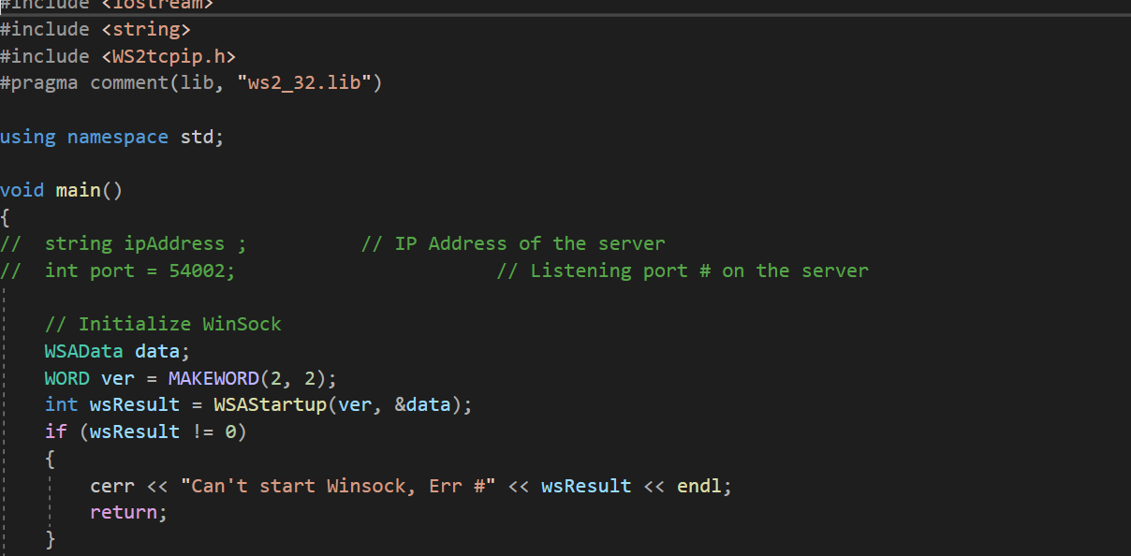

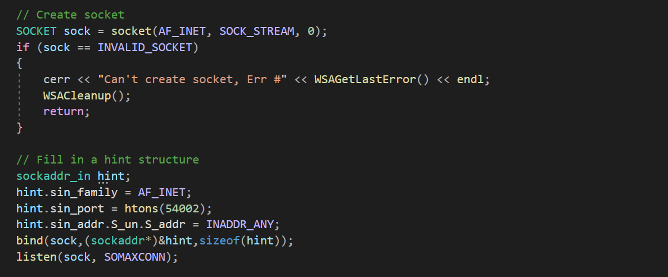

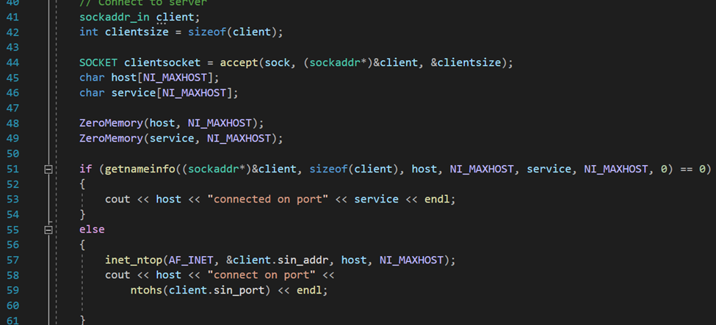

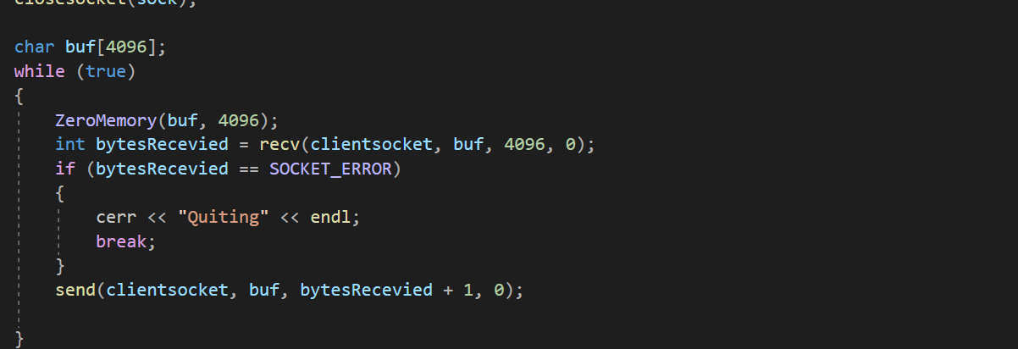

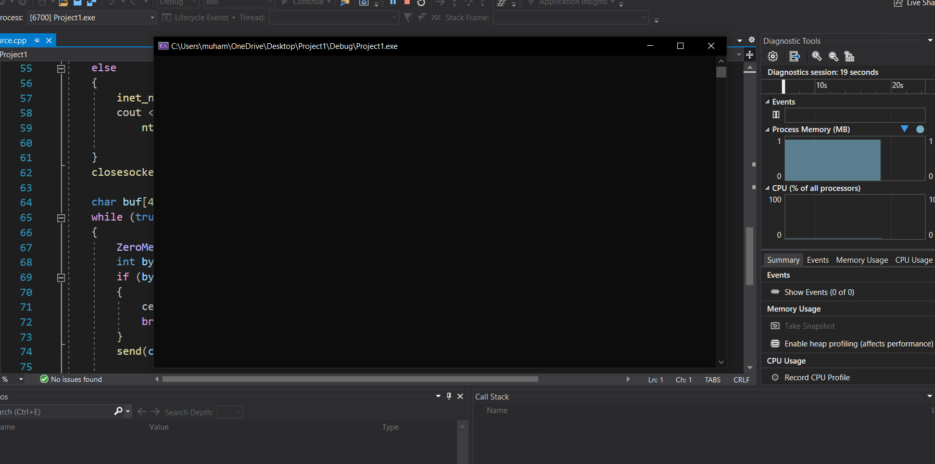

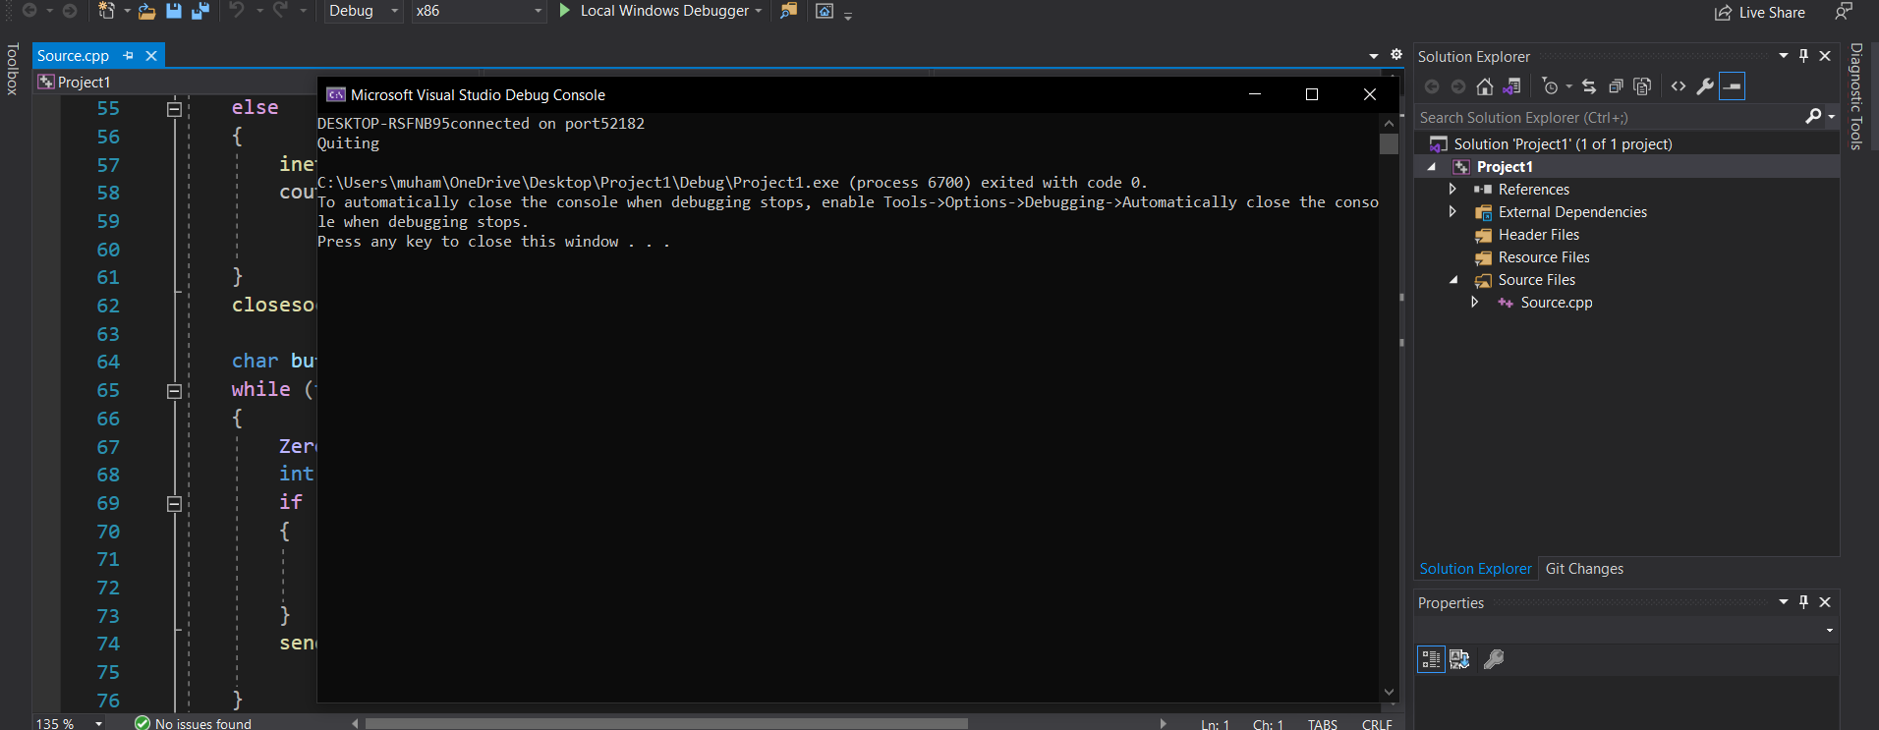

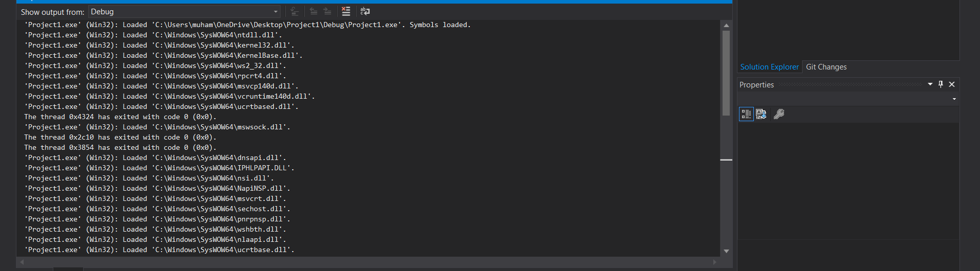

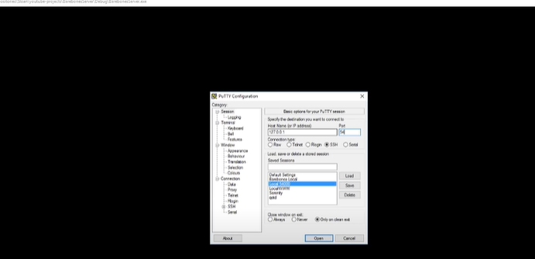

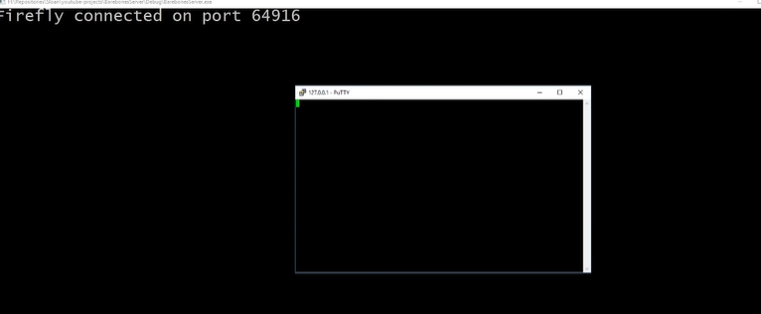

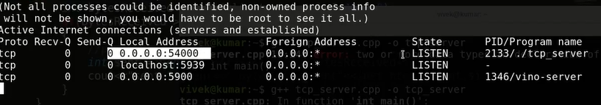
Encountered Problems:
- problems with my filenames or content not showing up correctly
- Idle connections are dropping
- Connection issue
- Connection timeout

Analysis
After this experiment, I have been able to learn to discover the transmission Control Protocol service
Opened by the remote host, understand the working principle of C/S communication mode and port scanning. Learned usage of some new software like putty. Learned to overcome bugs during the process.

